Net-Services Subnetting Class B

Part 1
a. Design an IP addressing layout for topology shown.
b. Use Basic Subnetting in your design.
- Name all routers and end devices as shown in topology.

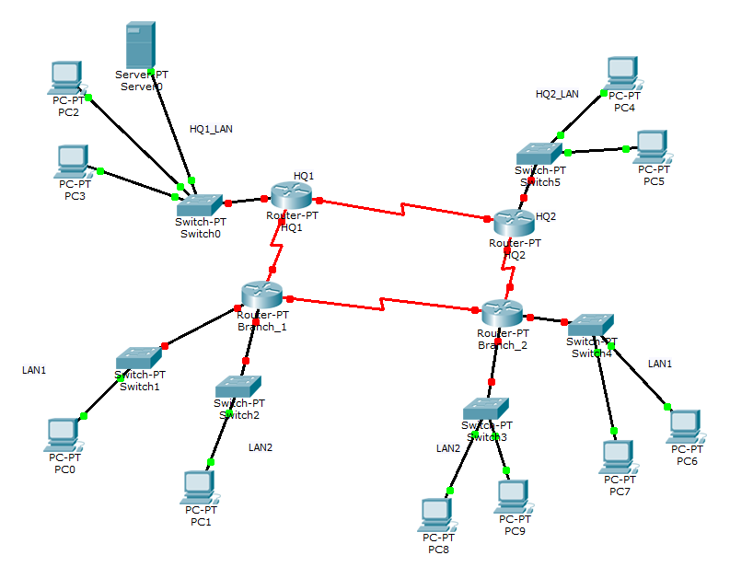

The global network address is 160.58.0.0 /16. Use basic subnetting so that the addressing requirements listed below can be met.

Requirements:

- The HQ1 LAN requires 1500 host IP addresses
- The HQ2 LAN requires 4000 host IP addresses
- The Branch 1 LAN1 requires 1000 host IP addresses
- The Branch 1 LAN2 requires 400 host IP addresses
- The Branch 2 LAN1 requires 120 host IP addresses
- The Branch 2 LAN2 requires 120 host IP addresses
- The Link from HQ1 to HQ2 will require an IP address for each end of the link.
- The Link from HQ1 to Branch 1 will require an IP address for each end of the link.
- The Link from HQ2 to Branch 2 will require an IP address for each end of the link
- The Link from Branch1 to Branch 2 will require an IP address for each end of the link

